MEMORIES OF THE TROOP SHIP ’ SIR LANCELOT’
ALSO REMEMBERED AS ‘ SIR LAUGH A LOT’
As seen thru the eyes of Ron Blood
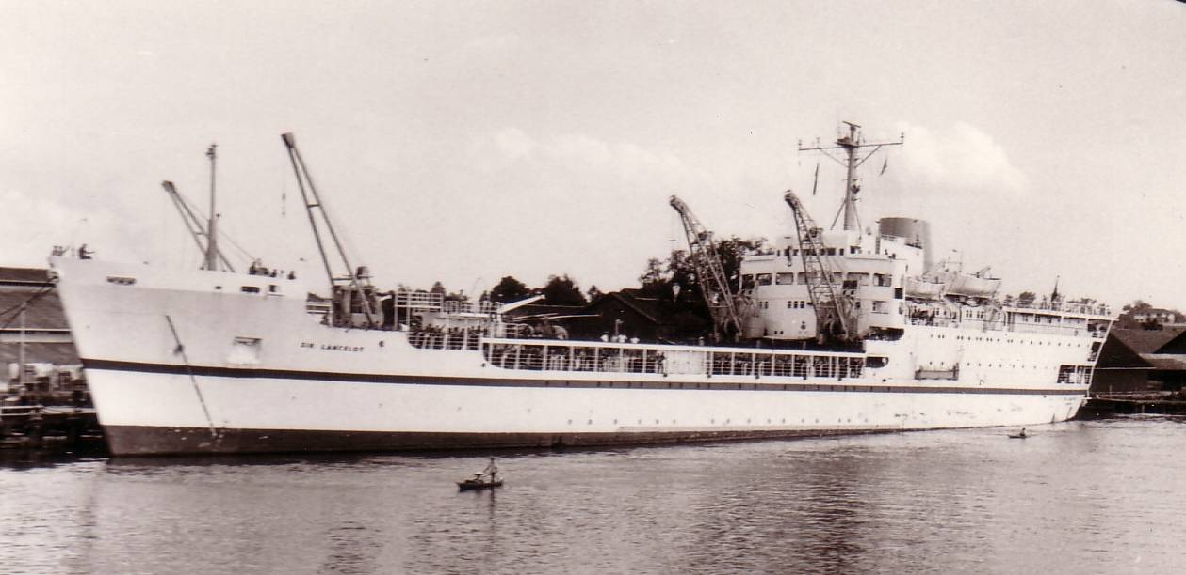

I find it hard to believe that the following story that I’m about to write, actually happened. But, I have been reliably informed by numerous people who were present during the following events that the story below did take place. The perpetrators of this despicable act were members of 12- Platoon, D- Company, 4RAR. The place; Singapore to Borneo and return.
12-Platoon’s first encounter with the English Navy and the young English Officer on board the luxurious troop ship “Sir Lancelot” (Sir Laugh A Lot ) occurred after boarding this magnificent vessel. The members of 12-Platoon, after being trucked down from Terendak Barracks to Singapore required some liquid sustenance. So, they, therefore, acquired the correct liquid replenishments and found a suitable area to participate in re-hydrating their drained bodies. Much to the dismay of the English Navy, the side of the ship was not a suitable place to participate in this activity according to the young English Officer, who strongly informed all of the offenders that this behaviour would not be tolerated and drinking would only take place in the bar provided for guests aboard his troop ship.
This suited the needs of the 12-Platoon members who followed the young English Officers instructions and participated in their drinking at the bar provided by the Navy. Within the hour, the young English Officer returned to confront the members of 12- Platoon who had followed his request to only drink in the bar area. Happily, the bar area was so small that, 12Platoon completely filled the area provided . Unhappily? no other personnel travelling on this particular voyage could enjoy the bar facilities.
12 Platoon much to the dismay and horror of the young English Officer was given permission to drink on the side of the ship. Another item which was bought to my attention while verifying the facts of this story, was a comment made by the Navy that we left a trail of empties from Singapore to Kuching. Round 1 to 12-Platoon.
The next encounter with the English Navy and the young English Officer was to occur on our return trip from Borneo to Singapore. On boarding the “Sir Lancelot” members of 12-Platoon took up a collection and sent the driver to buy ice from any place he could find it, on his return the platoon members had gathered all of the ships garbage cans ready to be filled with the ice. On the opening of the bar every member brought a carton of beer to put into the garbage cans. As can be expected from the English Navy especially the young English Officer this kind of behaviour was to be expected from the colonial louts that he had come to know on their trip to Borneo. So to keep the peace he decided that complaining would not accomplish anything, he, therefore, satisfied himself with a glare at the ungrateful passengers aboard his ship and went about his business.
The cruise from Borneo to Singapore went along as well as can be expected until the night before sailing into Singapore Harbour when the English Navy realised that further trouble may occur because of 12-Platoon, D Company, 4RAR.
In the early dawn light as the “Sir Lancelot” was about to enter Singapore Harbour, the English Navy noticed, flying from the stern of their magnificent craft, a skull and cross-bone flag, drawn on a sheet attached to the flag pole. As can be expected, I don’t why!!!, but the English Navy even the young English Officer thought that the offenders had to be that disreputable 12-Platoon , of 4RAR. With this thought in mind the young English Officer, now had a way in which he could make these unruly louts accountable. Unbeknown to him the perpetrators were ready for the English Navy.
Even though the culprits had used one of their own members sheet which was issued from the navy, for their evil purposes, during the night, thru their drunken haze they realised what actions the navy would take to catch the offenders and took the appropriate measures. The scoundrels who would dare to challenge the Royal Navy in such a disrespectable manner would be caught and dealt with in such a way that even death would be a better alternative punishment.
The young English Officer was given the job of going around the ship counting sheets to find out where the offending material had come from. Much to the young English Officers surprise the sheets issued to those trouble making Australians of 12-Platoon, 4RAR tallied with what was issued. A Company of Malaysian soldiers returning to Malaysia were found to be short a sheet, however, no action was taken against them. For some reason even without proof the stalwart soldiers of 12-Platoon, D Company of 4RAR. were blamed for this outrageous action against our hosts the English Navy and especially our friendly young English Officer who I must admit knew how to hold a grudge.
As a member of this crowd of hooligans of 12- Platoon, 4RAR. I take this opportunity without any admittance of guilt by any members of 12-Platoon to say thank you to the English Navy for the ride it sure beat swimming. Noel Smith just a quick thought, weren’t you the 12 Platoon Sergeant at the time of this incident!!!!!
But I don’t have any recollection of the platoon officer or the platoon sergeant having any type of punishment or recriminations against them, as did the rest of the platoon???????
As seen in this photo Kuching Harbour was certainly a modern industrial working harbour, capable of handling three ships at one time.
The crew of the ‘Sir Lancelot’ certainly had their work cut out for them at this particular harbour no wharf cranes to assist in the unloading. All unloading occurred by ships crane and hand.
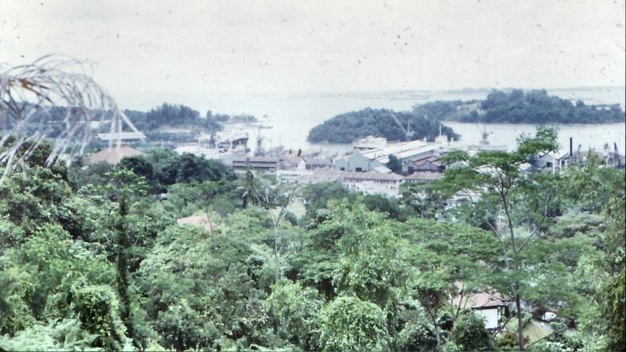
I thank Rollo Brett for his assistance in this bit of 4RAR History, which I am certain that the Army would love to forget.

4th BATTALION - ASSAULT PIONEER PLATOON
VIETNAM - 1968

Rear Row - L to R
Wayne. Butcher - Peter. Lazarevic - G. (Bear) Winchester - G. (Ned) Sutton - Richard. Foster
Phil. Gardener - G. (Felix) Barker - Len. Warner - M. Stone - Jeff. Cattermole - Robert. Strong

Centre Row - L to R
R. (Prof) Moore - R. (Darcy) Duggan - Ron. Blood - A. (Stewie) Lowe - Len. Pill - J. (Pud) Darlington
A. (Wallaby) Wilkes - P. (Scotty) Clayton - Ian. Butterly - ?. (Pommy) Taylor - Ron. Templeman

Front Row - L to R
Don. Millson - W. (Turtle) Thomas - Bruce. Howieson - P. (Bomber) Butler - Denny. Cook
Phil. Graham - W. (Pinky) Parker - Wally. Bray - Billy Walpole

Absent our Gallant Leader : Chris Pepper + 1 Colin Lovi

