MEMORIES

This will really test the memory banks , 4th Battalion, the Royal Australian Regiment, formed up for a Battalion Parade on the Adelaide Oval on the 11th April 1964, to be presented the Queens and Regimental Colours by the Governor General, The Right Honourable Viscount De L’isle VC, KG, GCMG, GCVO. PC.
This made 4th Battalion of the Royal Australian Regiment the first Battalion of the Regiment to be raised on Australian soil.
It was at the presentation of the Colours that the Governor General requested that the Pioneer Sergeant grow a beard, making him the only person in the Australian Army allowed to have a beard.
I apologise for not putting photo’s of the battalion receiving their Colours, in early editions of the Scarlet and White Newsletter.
This was due to the fact I couldn’t locate any one until now who had photographs of this monumental occasion. Even Noel (Mad-Dog) Smith would have to admit the members parading look pretty smartly turned out. I must have been in the rear out of camera shot, as they didn’t want to show you all being out of step with me.

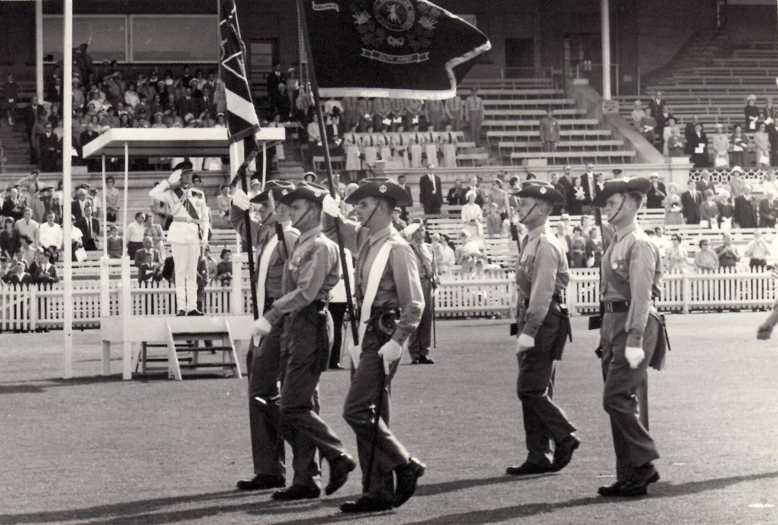

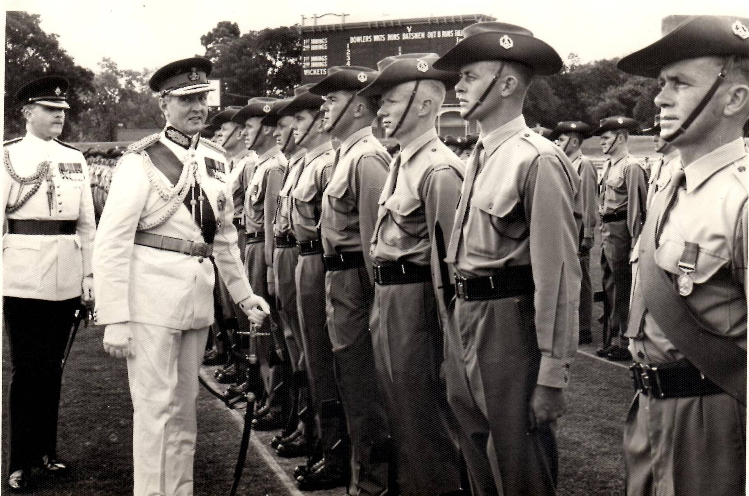

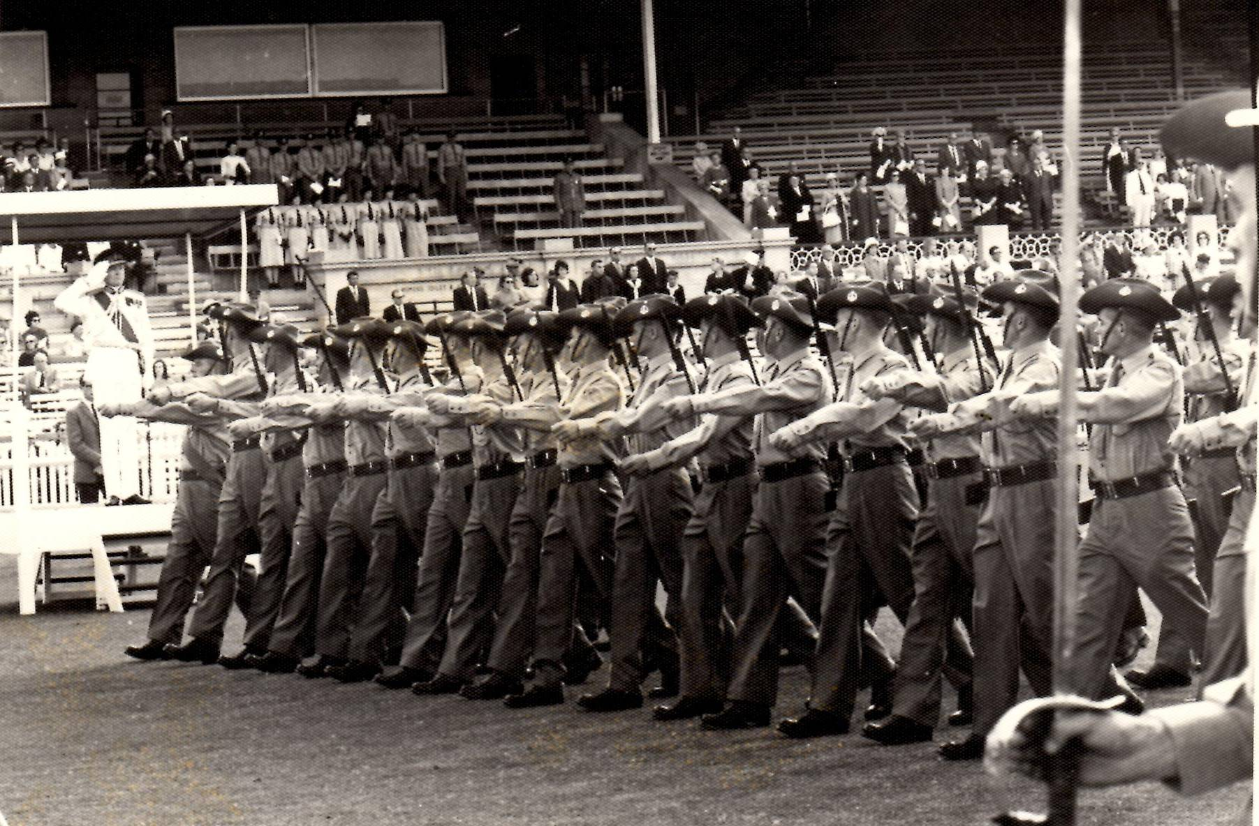

Looking at the photo it’s difficult to believe we were that fit and thin.

